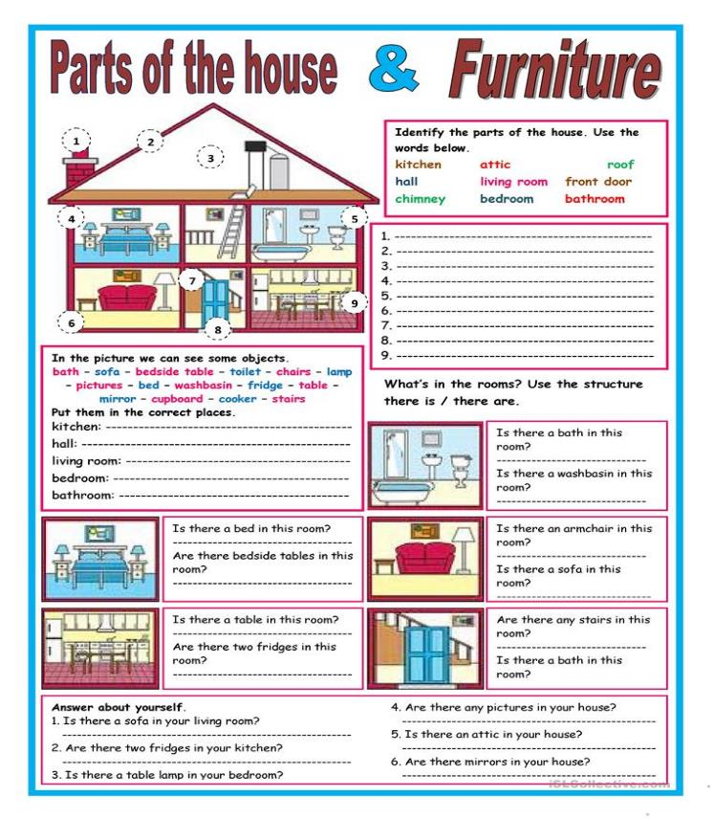

* **1. Organize the words in the correct order.**

1. name / complete / _______ / is / my

_________________________________________________________________________________________

1. in Maringá / at UEM / ILG / is / a Language School

_________________________________________________________________________________________

1. I'm / British / French / I'm / not

_________________________________________________________________________________________

1. sisters / Margaret / are / and / my / Melanie

_________________________________________________________________________________________

1. Paris / capital / the / of / France / is

_________________________________________________________________________________________

1. are / we / you / happy / to / very / see

_________________________________________________________________________________________

1. is / is / brother / John / my / and / he / 24 years old

_________________________________________________________________________________________

1. very / you / are / good / a / student

_________________________________________________________________________________________

1. we / here / very / are / to / be / happy

_________________________________________________________________________________________

1. this / is / expensive / is / very / house / and / it / big

_________________________________________________________________________________________

* **Complete the chart:**

**Abu Dhabi Brazil London Spain Canberra Chinese Argentina Bangkok**

**Tokyo Sweden Panama Peru Cairo Ottawa Portugal Rome Switzerland Paris Mexican Netherlands Soul Germany Russia Greek**

**Scotish Thailand Wales Turkish Kingston India Washington D.C.**

* **Draw the flag and paint it**

|  |  |  |  |
| --- | --- | --- | --- |
| **FLAG** | **COUNTRY** | **CAPITAL** | **NATIONALITY** |
|  | United Arab Emirates | Abu Dhabi | Emirati |
|  | Brazil | Brasilia | Brazilian |
|  |  |  |  |
|  |  |  |  |
|  |  |  |  |
|  |  |  |  |
|  |  |  |  |
|  |  |  |  |
|  |  |  |  |
|  |  |  |  |
|  |  |  |  |
|  |  |  |  |
|  |  |  |  |
|  |  |  |  |
|  |  |  |  |
|  |  |  |  |
|  |  |  |  |
|  |  |  |  |
|  |  |  |  |
|  |  |  |  |
|  |  |  |  |
|  |  |  |  |
|  |  |  |  |
|  |  |  |  |
|  |  |  |  |
|  |  |  |  |
|  |  |  |  |
|  |  |  |  |
|  |  |  |  |
|  |  |  |  |
|  |  |  |  |
|  |  |  |  |
|  |  |  |  |

